Lab Work 5: Time Series Forecasting with LSTM
Name: Al Amin Hossain Nayem
Date: April 6, 2025

Objective
The goal of this lab work is to implement a Long Short-Term Memory (LSTM) model to forecast SO₂ (Sulfur Dioxide) concentrations 1 to 4 hours ahead based on past observations. The model is trained on January 2018 data and tested on February 2018 data.
Tools and Libraries
- Python
- PyTorch
- NumPy
- Matplotlib
Dataset
- Training set: 2018_01_so2.npy
- Testing set: 2018_02_so2.npy
Code Overview
Dataset Preparation
The TimeSeriesDataset class is used to generate sequences:
- Input window size: 24 hours
- Output window size: 4 hours
Model Definition
An LSTM network with:
- Input size = 1
- Hidden size = 128
- 2 layers
- Dropout = 0.2
- Fully connected (FC) layer outputs 4 values for next 4 hours.
Normalization
The data is normalized using the training set's mean and standard deviation.
Training
- Optimizer: Adam
- Learning rate: 0.001
- Loss function: Mean Squared Error (MSE)
- Epochs: 150
- Batch size: 64
Testing and Evaluation
- Total test loss is computed.
- Individual loss is computed for each of the 4 prediction hours.
- True and predicted values are plotted for each forecast horizon.
Results
Loss during Training
Loss steadily decreased across 150 epochs, indicating successful model convergence.
Testing Results
- Total Test Loss (MSE): (Shown in the console)
- Individual Losses:
  - 1 hour ahead: (Shown in the console)
  - 2 hours ahead: (Shown in the console)
  - 3 hours ahead: (Shown in the console)
  - 4 hours ahead: (Shown in the console)
Plots
Graphs were generated comparing true vs. predicted SO₂ concentrations for:
- 1 hour ahead
- 2 hours ahead
- 3 hours ahead
- 4 hours ahead
These plots demonstrate that the model captures the temporal pattern well but with increasing error as prediction horizon extends.
Conclusion
An LSTM-based model was successfully built and trained to forecast short-term SO₂ concentrations. The model shows good predictive performance for immediate future steps but degrades slightly for farther steps. The performance could be further improved by:
- Tuning hyperparameters (e.g., hidden size, learning rate)
- Using more complex architectures (e.g., attention mechanisms)
- Training on more data.
Figures:
# -*- coding: utf-8 -*-
"""
Created on Sun Apr 6 10:49:57 2025
@author: ginta
"""

import torch
import torch.nn as nn
import torch.optim as optim
from torch.utils.data import Dataset, DataLoader
import numpy as np
import matplotlib.pyplot as plt

# Define the Dataset
class TimeSeriesDataset(Dataset):
def __init__(self, series, input_window=24, output_window=4):
self.series = series
self.input_window = input_window
self.output_window = output_window
self.samples = []
for i in range(len(series) - input_window - output_window + 1):
x = series[i : i + input_window]
y = series[i + input_window : i + input_window + output_window]
self.samples.append((x, y))

def __len__(self):
return len(self.samples)

def __getitem__(self, index):
x, y = self.samples[index]
return torch.tensor(x, dtype=torch.float32).unsqueeze(-1), torch.tensor(y, dtype=torch.float32)

# Define the Model
class LSTMModel(nn.Module):
def __init__(self, input_size=1, hidden_size=128, num_layers=2, output_size=4):
super(LSTMModel, self).__init__()
self.hidden_size = hidden_size
self.num_layers = num_layers

self.lstm = nn.LSTM(input_size, hidden_size, num_layers, batch_first=True, dropout=0.2)
self.fc = nn.Linear(hidden_size, output_size)

def forward(self, x):
h0 = torch.zeros(self.num_layers, x.size(0), self.hidden_size).to(x.device)
c0 = torch.zeros(self.num_layers, x.size(0), self.hidden_size).to(x.device)
out, _ = self.lstm(x, (h0, c0))
out = out[:, -1, :]
out = self.fc(out)
return out

# Load and normalize the data
train = np.load('2018_01_so2.npy')
test = np.load('2018_02_so2.npy')

# Normalize
train_mean = train.mean()
train_std = train.std()

train = (train - train_mean) / train_std
test = (test - train_mean) / train_std

# Create Dataset and DataLoader
dataset = TimeSeriesDataset(train, input_window=24, output_window=4)
dataloader = DataLoader(dataset, batch_size=64, shuffle=True)

# Hyperparameters
num_epochs = 150
learning_rate = 0.001

# Model, Loss, Optimizer
model = LSTMModel(input_size=1, hidden_size=128, num_layers=2, output_size=4)
criterion = nn.MSELoss()
optimizer = optim.Adam(model.parameters(), lr=learning_rate)

# Training loop
for epoch in range(num_epochs):
model.train()
epoch_loss = 0.0
for x_batch, y_batch in dataloader:
optimizer.zero_grad()
predictions = model(x_batch)
loss = criterion(predictions, y_batch)
loss.backward()
optimizer.step()
epoch_loss += loss.item()

avg_loss = epoch_loss / len(dataloader)
print(f"Epoch {epoch+1}/{num_epochs}, Loss: {avg_loss:.6f}")

# Testing
model.eval()
dataset_test = TimeSeriesDataset(test, input_window=24, output_window=4)
full_batch_loader = DataLoader(dataset_test, batch_size=len(dataset_test), shuffle=False)

for x_full, y_full in full_batch_loader:
with torch.no_grad():
predictions = model(x_full)

# Calculate total test loss
total_loss = criterion(predictions, y_full)
print(f"\nTotal Test Loss (MSE): {total_loss:.6f}")

# Calculate individual losses for each of the 4 output steps
for i in range(4):
step_loss = criterion(predictions[:,i], y_full[:,i])
print(f"Test Loss for {i+1} hour(s) ahead: {step_loss:.6f}")

# Convert predictions and targets back to numpy (and denormalize for plotting if needed)
Predictions = predictions.cpu().numpy() * train_std + train_mean
Targets = y_full.cpu().numpy() * train_std + train_mean

# Plot true vs predicted for each forecast step
for i in range(4):
plt.figure(figsize=(10, 4))
plt.plot(Targets[:,i], label="True Values")
plt.plot(Predictions[:,i], label="Predicted Values")
plt.title(f"SO₂ Concentration Prediction {i+1} hour(s) ahead")
plt.xlabel("Sample Index")
plt.ylabel("SO₂ Concentration")
plt.legend()
plt.grid(True)
plt.show()
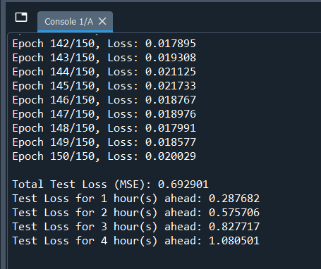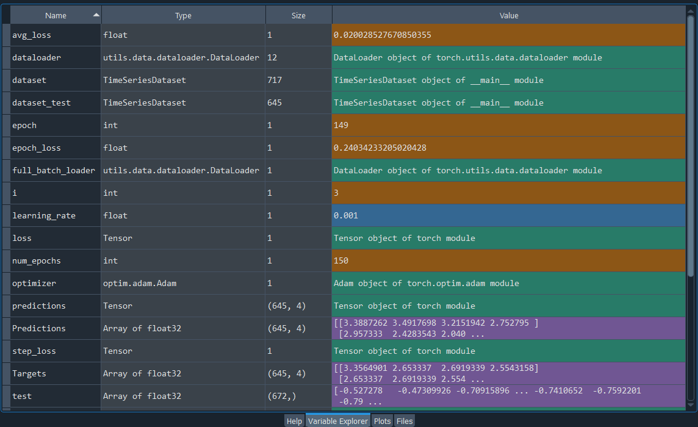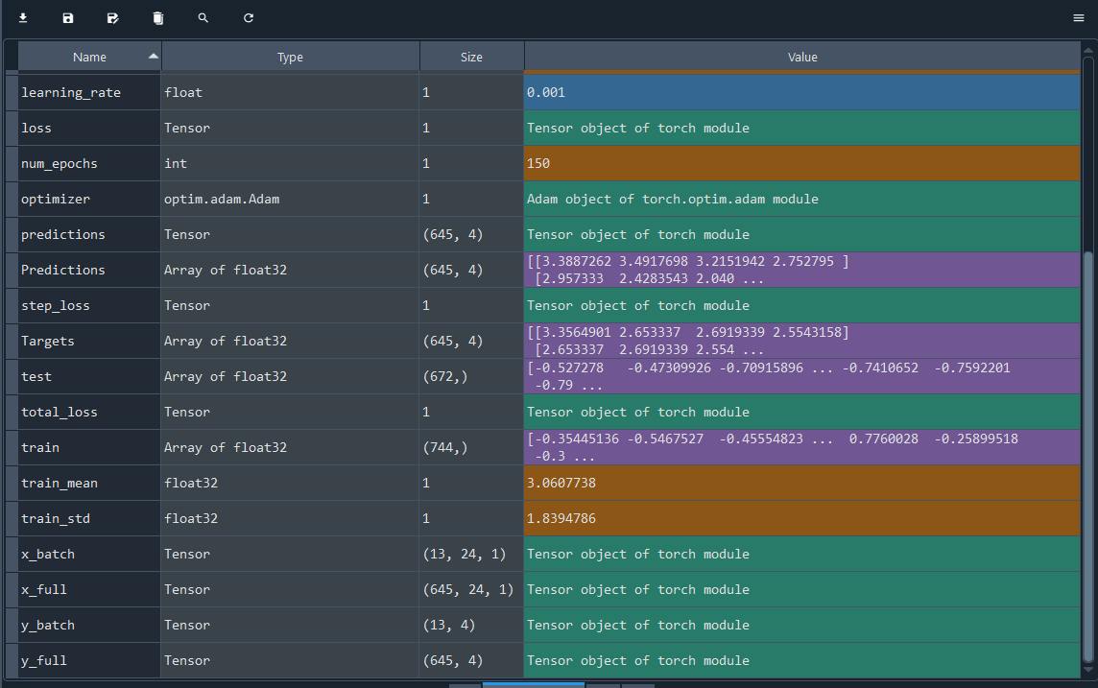

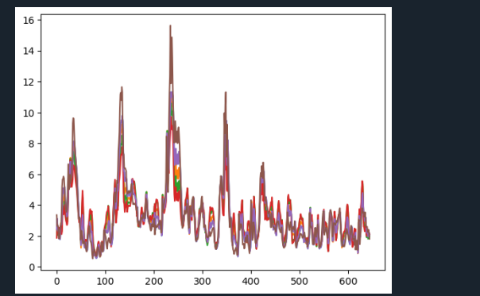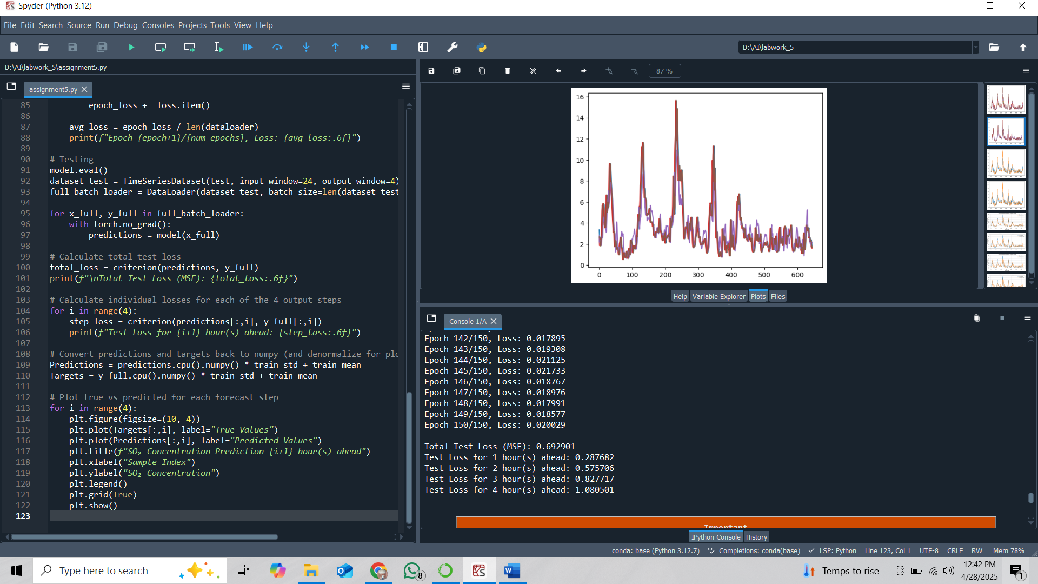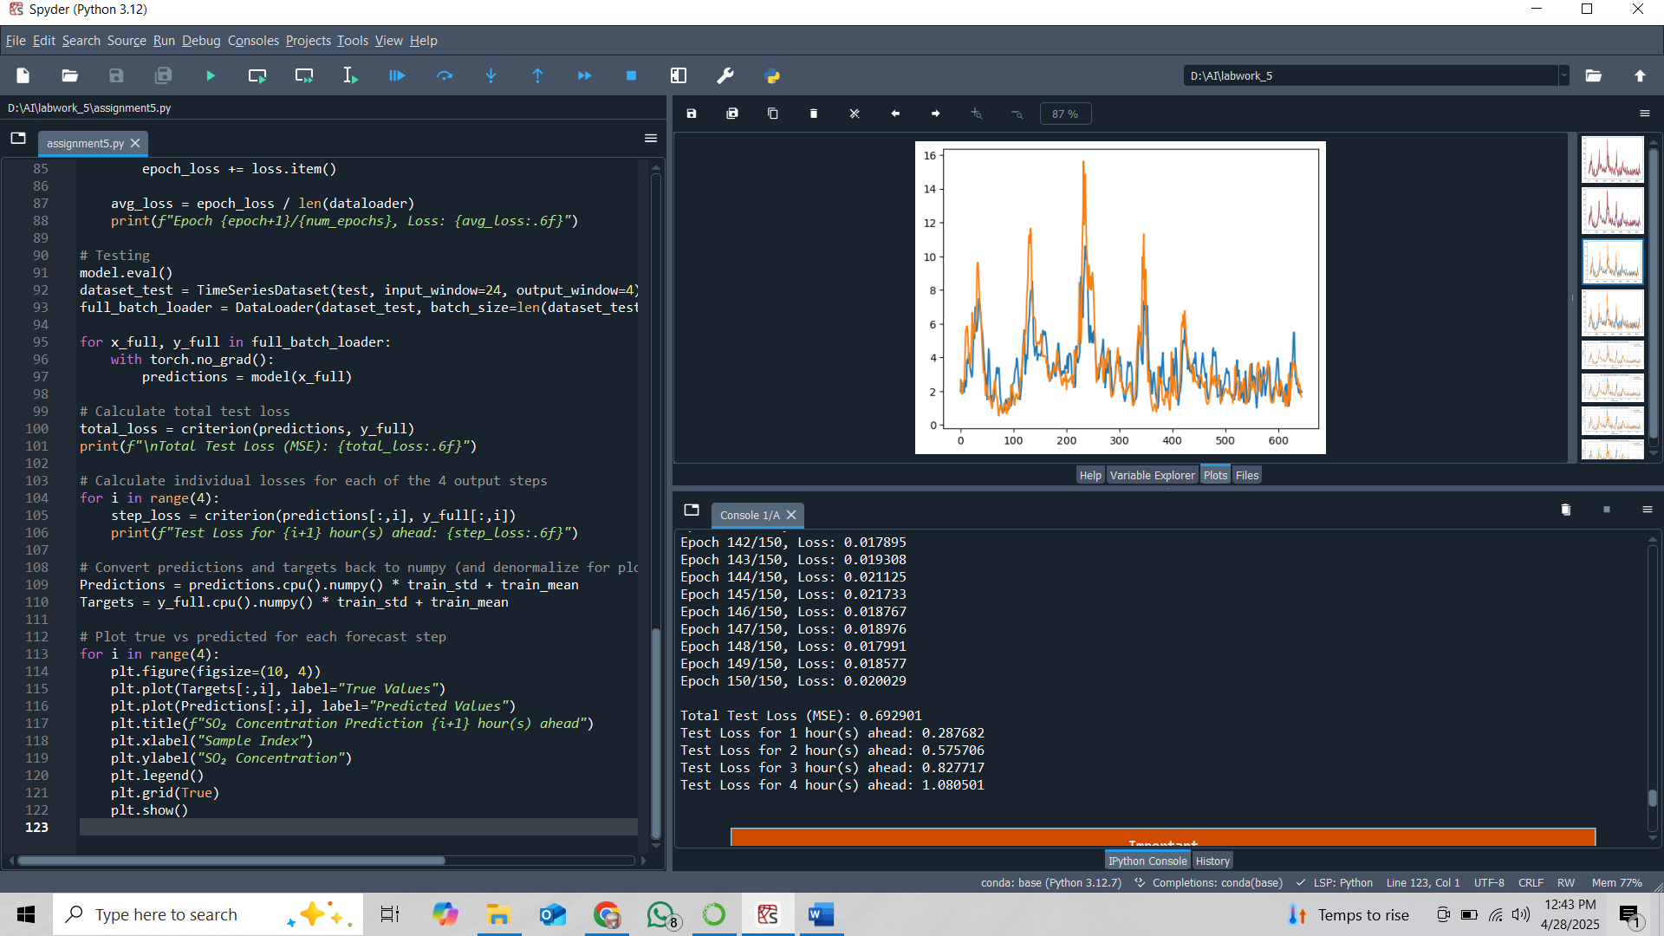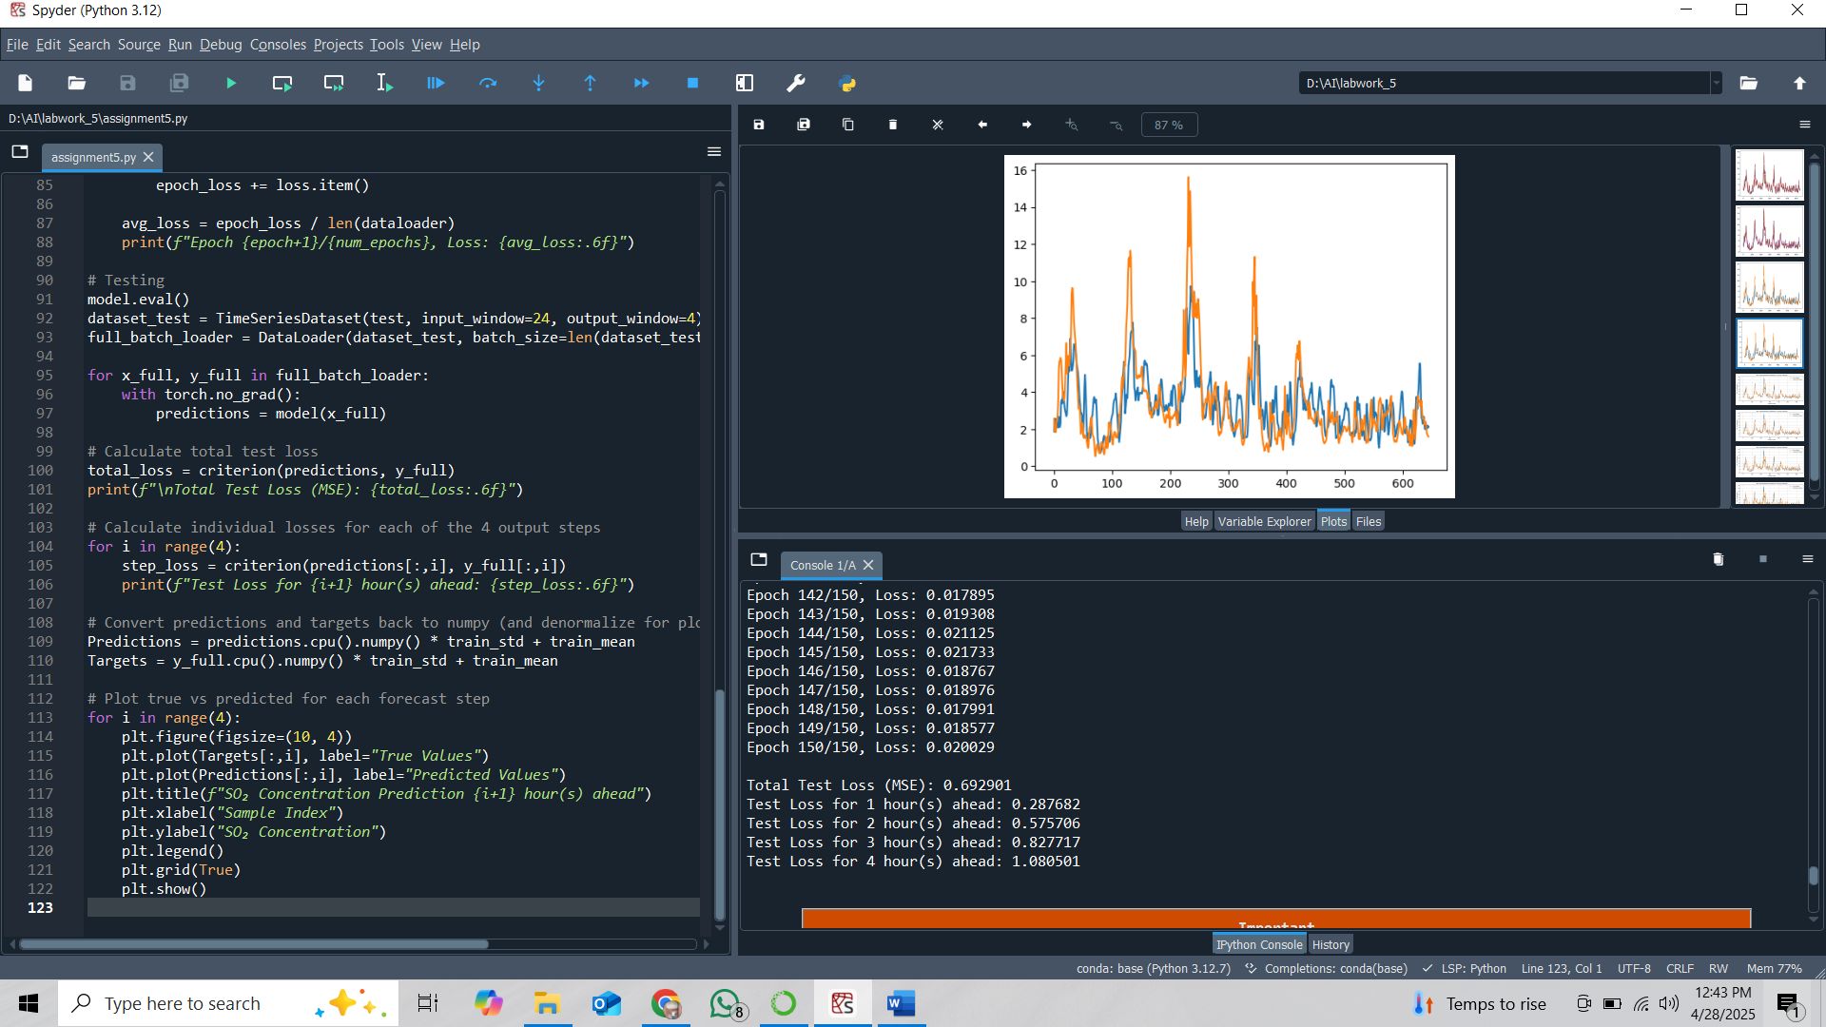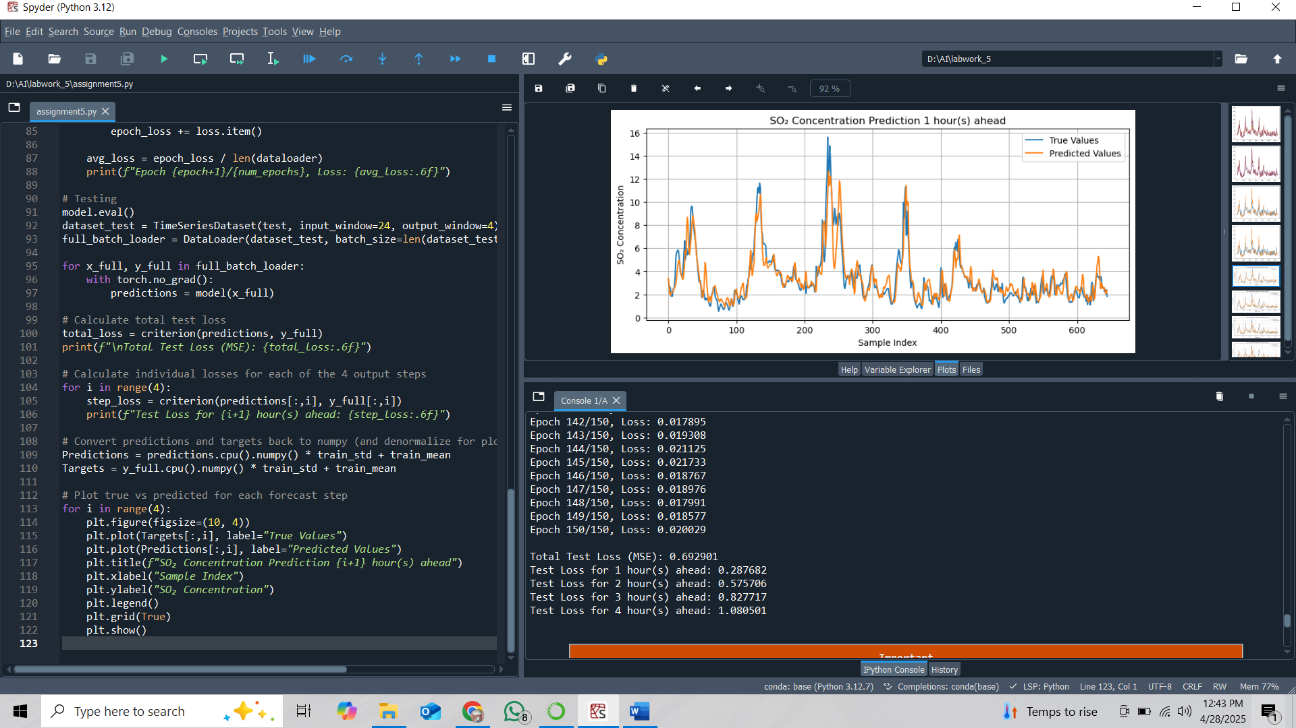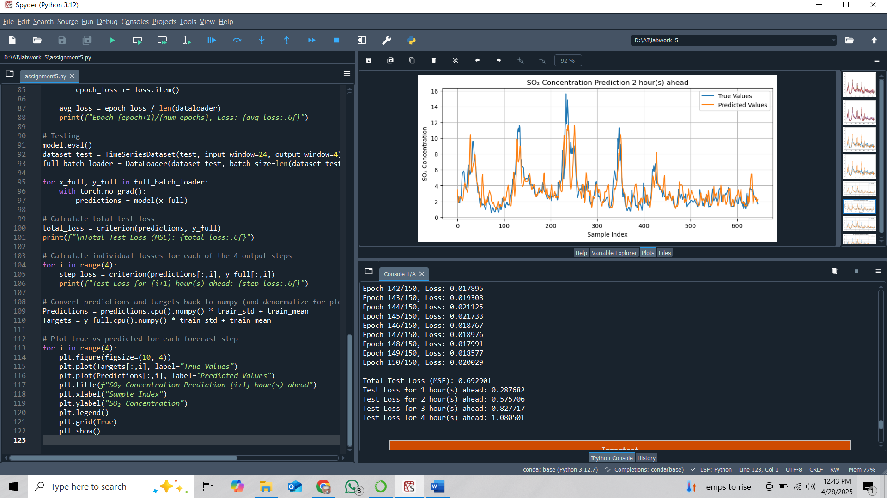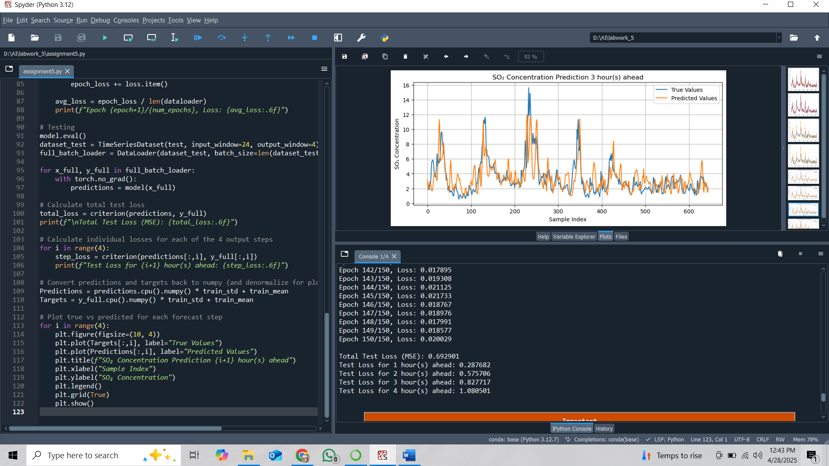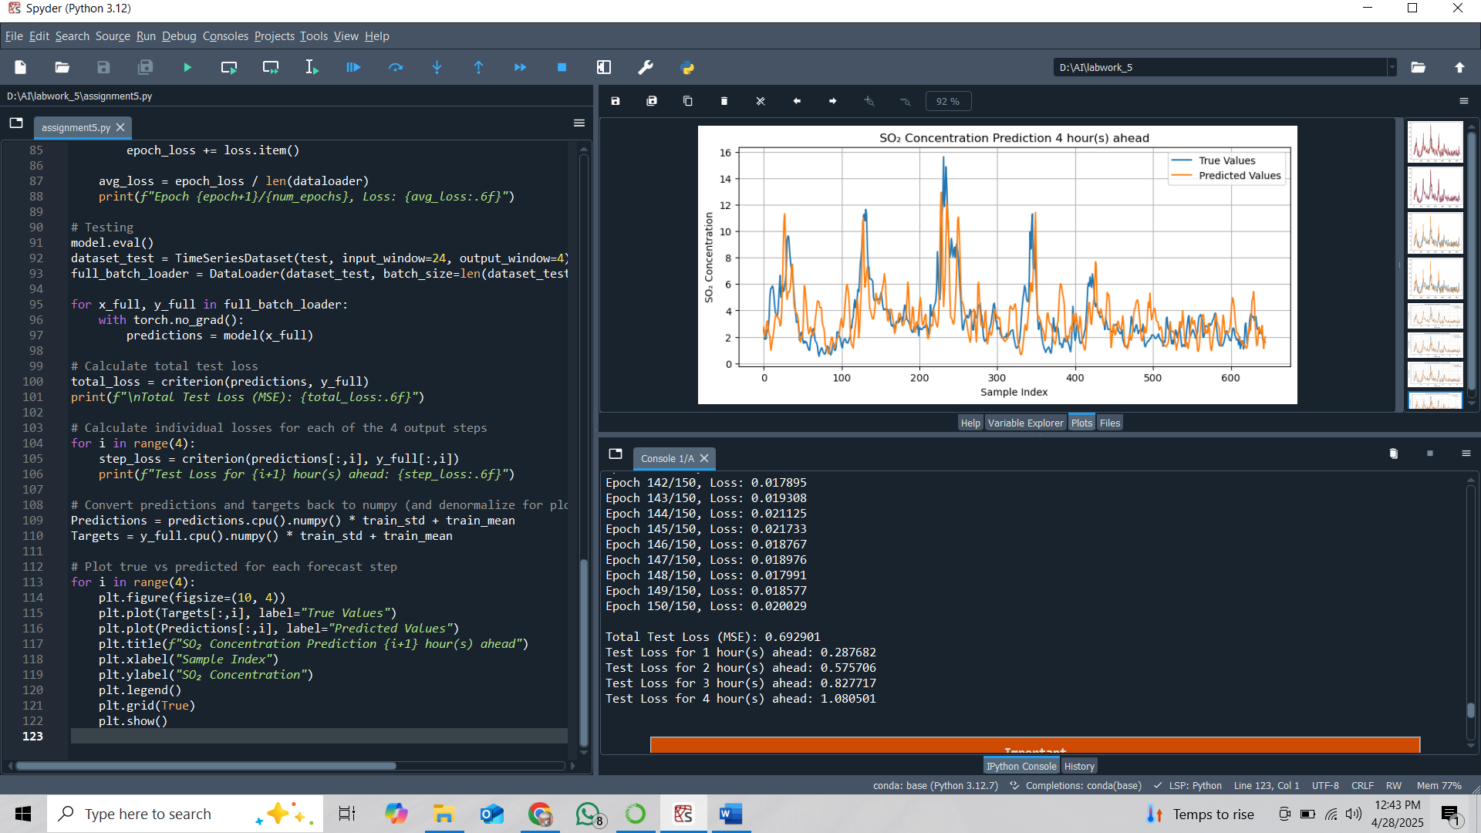

End of Lab Report

